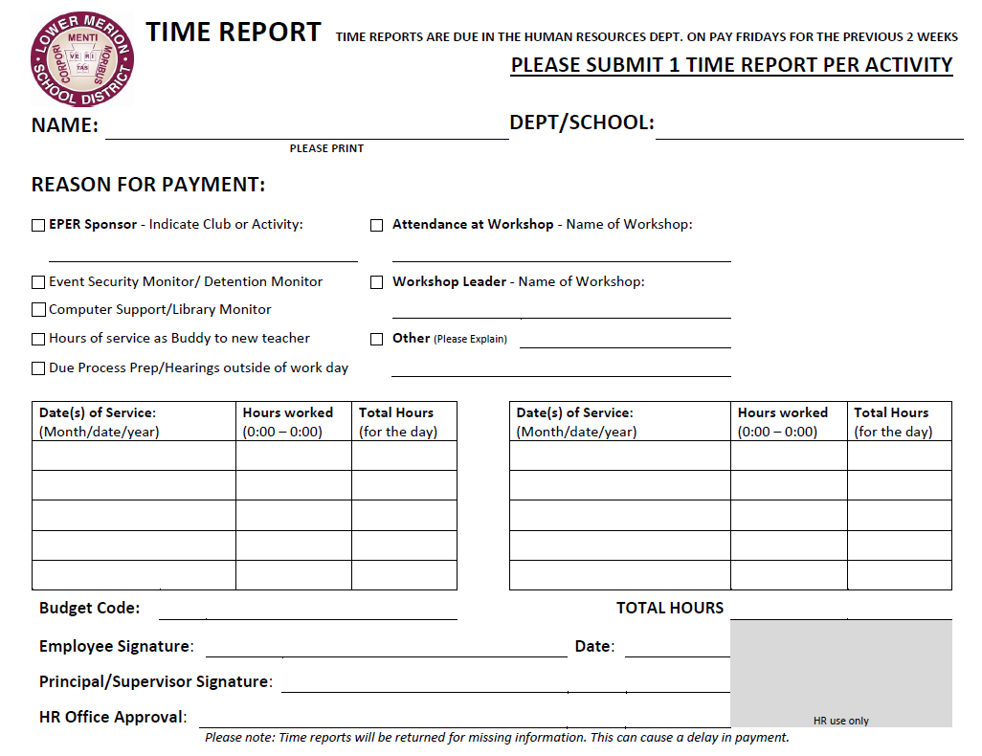
NAME
Bala Cynwyd Middle School
See attached for details…
X
BC Applause Theatre
HOURS
DATE

LMSD Time Report - Specific Hours
NAME
Name: _____________________________
Dates of Service:  (Month/date/year) | Service Details | Total Hours  (for the day)
HOURS
TOTAL HOURS _____________________

